**CHAPTER III**

**RESULTS AND DISCUSSION**

This chapter demonstrates the progress and assessment of the QR Code Attendance Monitoring with Class Scheduling Management System based on data gathered from a questionnaire conducted at Bago Elementary School. Respondents in this study were categorized into two main classifications: IT professionals and end users. Following the ISO 25010 software quality standards, these professionals and end users were requested to evaluate the technical quality of the QR Code Attendance Monitoring with Class Scheduling Management System.

1. **Development of the QR Code Attendance Monitoring with Class Scheduling Management System based on the phases of the stages of Agile Model.**

The development of the QR Code Attendance Monitoring with Class Scheduling Management System went through the six (6) stages of the Agile Model as describe below.

**Requirements Analysis Stage**

The researchers performed a variety of tasks, such as observations, brainstorming, and interviews. Their aim was to create a strategy for how the developed system should integrate with the existing processes and provide solutions to the problems faced by the researchers. Additionally, they developed a Gantt chart outlining the different stages of the Agile Model to serve as a guide for the construction of the system.

**Gantt Chart**

Figure 3 shows the schedule of activities that the researchers underwent during the course of development of the QR Code Attendance Monitoring with Class Scheduling Management System.

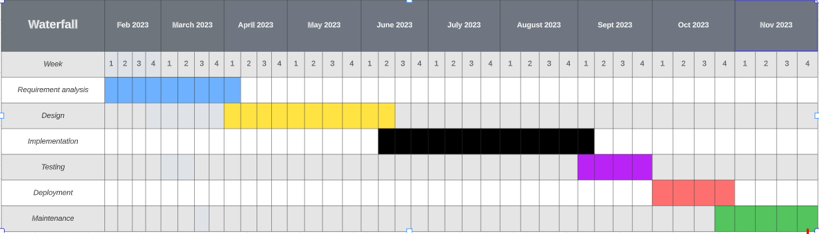

**Fig. 3.**Gantt chart of Activities

**Design Stage**

In this crucial phase of our research journey, our dedicated team of researchers diligently crafted a series of straightforward diagrams. Our primary objective during this endeavor was to attain a profound and comprehensive understanding of the pivotal activities and processes intrinsic to the system we had painstakingly developed.

Through the creation of these diagrams, our aim was to uncover the intricate details and interconnections within the system, thus facilitating a holistic perspective of its functionality. This in-depth analysis would, in turn, empower us to make informed decisions and identify opportunities for enhancement. Our commitment to meticulousness and thoroughness in our examination left no aspect of the system unexplored. This dedication underscored our unwavering pursuit of excellence in research and the continuous improvement of our system.

**Data Flow Diagram**

Figure 4 presents the context diagram for the developed system, outlining external entities and the processes encapsulated within the QR Code Attendance Monitoring with Class Scheduling Management System.

**PICTUREEEEEEEE**

Figure 5 shows the level 1 representation of the data flow diagram. It has 2 entities, user and admin.

**Use-case Diagram**

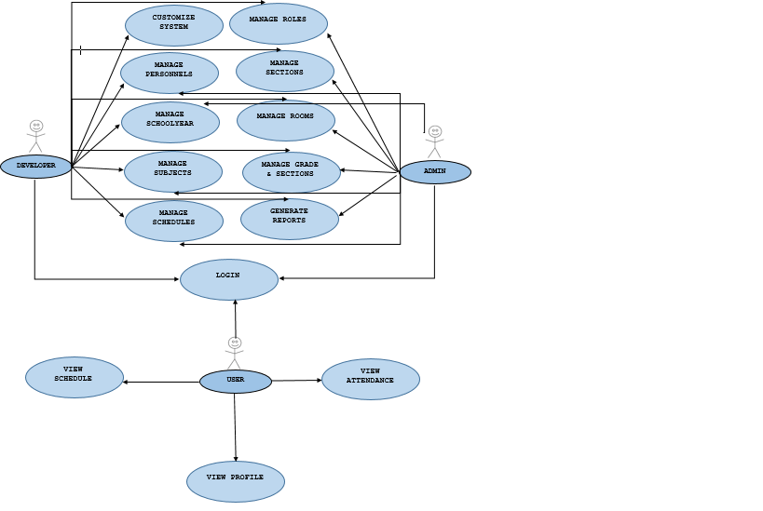

**HIPO Chart**

Figure 7 shows hipo chart of the developed system. It represents the programs control structure in QR Code Attendance Monitoring with Class Scheduling Management System.

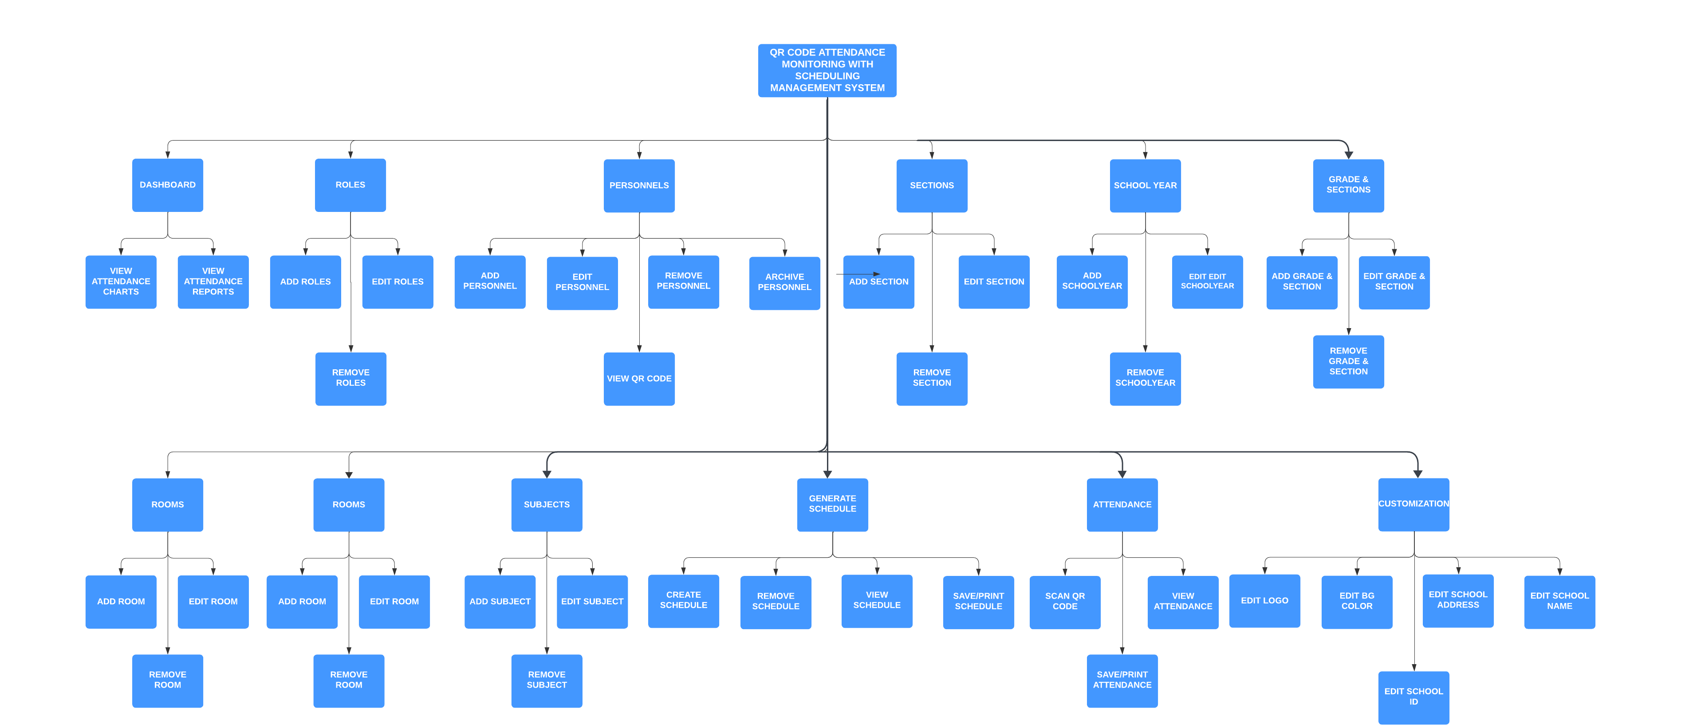

**Entity-Relationship Diagram**

Figure 8 shows the ERD for a QR Code Attendance with Scheduling Management System requires a comprehensive understanding of the system's requirements, entities, relationships, and attributes.

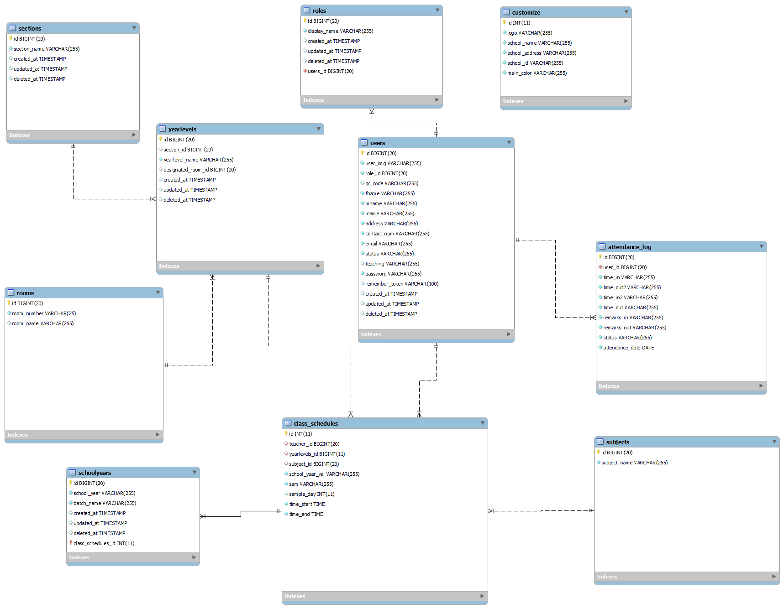

**Database Normalization**

**pictureeeeeeee**

**Data Dictionary**

Data dictionary is a collection of descriptions of the data objects or items in a data model. It was made to enable other programmers to understand every entity belonging in a relation.

Figure 10 shows the data dictionary of the tables used to develop the QR Code Attendance Monitoring with Class Scheduling Management System.

**ATTENDANCE LOG**

|  |  |  |  |  |
| --- | --- | --- | --- | --- |
| **FIELD NAME** | **DATA TYPE** | **FIELD LENGTH** | **KEY** | **DESCRIPTION** |
| ID | BIG INT | 20 | PRIMARY | ATTENDANCE LOG ID, AUTO INCREMENT |
| USER_ID | BIG INT | 20 | FOREIGN | ID OF THE USER |
| TIME_IN | VARCHAR | 255 |  | USER TIME IN TIME |
| TIME_OUT2 | VARCHAR | 255 |  | USER AFTERNOON TIME OUT |
| TIME_IN2 | VARCHAR | 255 |  | USER AFTERNOON TIME IN |
| TIME_OUT | VARCHAR | 255 |  | USER TIME OUT |
| REMARKS_IN | VARCHAR | 255 |  | TIME IN REMARKS |
| REMARKS OUT | VARCHAR | 255 |  | TIME OUT REMARKS |
| STATUS | VARCHAR | 255 |  | USER ATTENDANCE STATUS |
| ATTENDANCE_DATE | DATE |  |  | ATTENDANCE LOG DATE |

**CLASS SCHEDULES**

|  |  |  |  |  |
| --- | --- | --- | --- | --- |
| **FIELD NAME** | **DATA TYPE** | **FIELD LENGTH** | **KEY** | **DESCRIPTION** |
| ID | BIG INT | 20 | PRIMARY | ATTENDANCE LOG ID, AUTO INCREMENT |
| TEACHER_ID | BIG INT | 20 | FOREIGN | ID OF USER |
| YEARLEVELS_ID | BIG INT | 20 | FOREIGN | ID OF YEAR_LEVELS |
| SUBJECT_ID | BIG INT | 20 | FOREIGN | ID OF SUBJECTS |
| SCHOOL_YEAR_VAL | VARCHAR | 255 |  | SCHOOL YEAR |
| SEM | VARCHAR | 255 |  | SEMESTER |
| SAMPLE_DAY | INT | 11 |  | INDEX VALUE OF DAY |
| TIME_START | TIME |  |  | START TIME OF THE SCHEDULE |
| TIME_END | TIME |  |  | END TIME OF THE SCHEDULE |

**CUSTOMIZE**

|  |  |  |  |  |
| --- | --- | --- | --- | --- |
| **FIELD NAME** | **DATA TYPE** | **FIELD LENGTH** | **KEY** | **DESCRIPTION** |
| ID | INT | 11 | PRIMARY | ID OF CUSTOMIZE |
| LOGO | VARCHAR | 255 |  | SCHOOL LOGO |
| SCHOOL_NAME | VARCHAR | 255 |  | SCHOOL NAME |
| SCHOOL_ADDRESS | VARCHAR | 255 |  | SCHOOL ADDRESS |
| SCHOOL_ID | VARCHAR | 255 |  | SCHOOL ID |
| MAIN_COLOR | VARCHAR | 255 |  | BACKGROUND COLOR |

**ROLES**

|  |  |  |  |  |
| --- | --- | --- | --- | --- |
| **FIELD NAME** | **DATA TYPE** | **FIELD LENGTH** | **KEY** | **DESCRIPTION** |
| ID | BIGINT | 20 | PRIMARY | ID OF ROLES |
| DISPLAY_NAME | VARCHAR | 255 |  | ROLES DISPLAY NAME |

**ROOMS**

|  |  |  |  |  |
| --- | --- | --- | --- | --- |
| **FIELD NAME** | **DATA TYPE** | **FIELD LENGTH** | **KEY** | **DESCRIPTION** |
| ID | BIG_INT | 20 | PRIMARY | ID OF ROOMS |
| ROOM_NUMBER | VARCHAR | 255 |  | ROOM NUMBER |
| ROOM_NAME | VARCHAR | 255 |  | ROOM NAME |

**SCHOOLYEARS**

|  |  |  |  |  |
| --- | --- | --- | --- | --- |
| **FIELD NAME** | **DATA TYPE** | **FIELD LENGTH** | **KEY** | **DESCRIPTION** |
| ID | BIGINT | 20 | PRIMARY | ID OF SCHOOLYEARS |
| SCHOOL_YEAR | VARCHAR | 255 |  | SCHOOL YEAR |
| BATCH_NAME | VARCHAR | 255 |  | BATCH NAME |

**SECTIONS**

|  |  |  |  |  |
| --- | --- | --- | --- | --- |
| **FIELD NAME** | **DATA TYPE** | **FIELD LENGTH** | **KEY** | **DESCRIPTION** |
| ID | BIG_INT | 20 | PRIMARY | ID OF SECTIONS |
| SECTION_NAME | VARCHAR2 | 255 |  | SECTION NAME |

**SECTIONS**

|  |  |  |  |  |
| --- | --- | --- | --- | --- |
| **FIELD NAME** | **DATA TYPE** | **FIELD LENGTH** | **KEY** | **DESCRIPTION** |
| ID | BIG_INT | 20 | PRIMARY | ID OF SECTIONS |
| SUBJECT_NAME | VARCHAR | 255 |  | SUBJECT NAME |

**YEARLEVELS**

|  |  |  |  |  |
| --- | --- | --- | --- | --- |
| **FIELD NAME** | **DATA TYPE** | **FIELD LENGTH** | **KEY** | **DESCRIPTION** |
| ID | BIG_INT | 20 | PRIMARY | ID OF YEARLEVELS |
| SECTION_ID | BIG_INT | 20 | FOREIGN KEY | ID OF SECTION |
| YEARLEVEL_NAME | VARCHAR | 255 |  | YEARLEVEL NAME |
| DESINATED_ROOM_ID | BIGINT | 20 | FOREIGN KEY | ID OF DESIGNATED ROOM |

**USERS**

|  |  |  |  |  |
| --- | --- | --- | --- | --- |
| **FIELD NAME** | **DATA TYPE** | **FIELD LENGTH** | **KEY** | **DESCRIPTION** |
| ID | BIG_INT | 20 | PRIMARY | ID OF YEARLEVELS |
| USER_IMG | VARCHAR | 255 |  | USER IMAGE |
| ROLE_ID | BIGINT | 20 | FOREIGN | ID OF ROLES |
| QR_CODE | VARCHAR | 255 |  | QR CODE |
| FNAME | VARCHAR | 255 |  | FIRST NAME |
| MNAME | VARCHAR | 255 |  | MIDDLE NAME |
| LNAME | VARCHAR | 255 |  | LAST NAME |
| ADDRESS | VARCHAR | 255 |  | ADDRESS |
| CONTACT_NUM | VARCHAR | 255 |  | CONTACT NUMBER |
| EMAIL | VARCHAR | 255 |  | EMAIL ADDRESS |
| STATUS | VARCHAR | 255 |  | STATUS |
| TEACHING | VARCHAR | 255 |  | IF USER IS TEACHING OR NOT |
| PASSWORD | VARCHAR | 255 |  | USER PASSWORD |

**Implementation Stage**

During this step, the researchers transformed the information collected during the design stage into a physical system. The actual code for the system was written using Visual Studio Code during the development phase. They also used PhpMyAdmin to create the database.

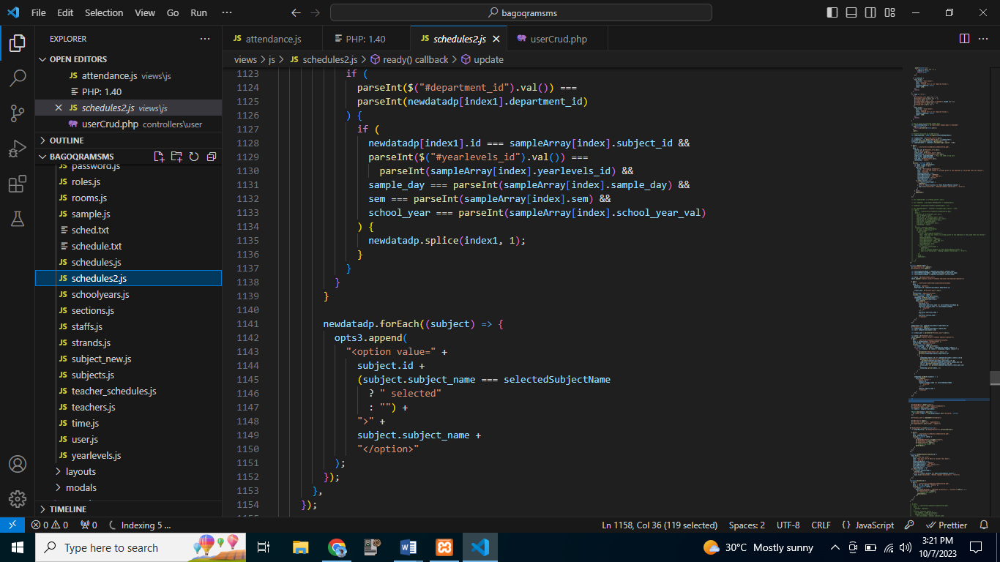

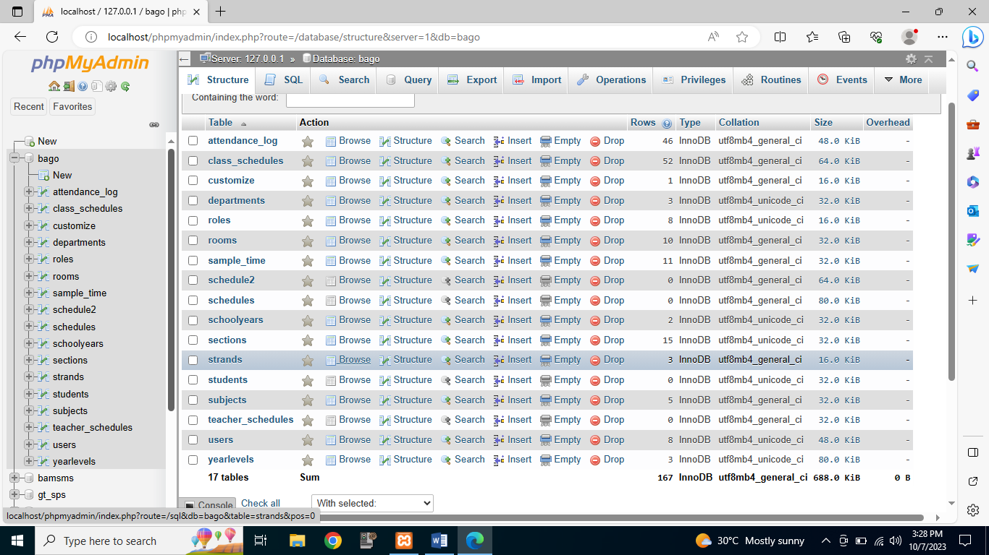

**Testing Stage**

At this point, the researchers employed functional testing to ensure that each function provided suitable input. Functional testing focuses on the system's primary functions, fundamental usability, accessibility, and error situations.

Mainline function testing involves researchers testing the system's primary functions to ensure that they are functioning properly. In basic usability testing, researchers study the system to see if the user can freely browse the screen and whether the buttons function properly.

The accessibility testing researchers examine the system to see if the user can browse the website without encountering any unknown system issues.

Lastly, the researchers evaluate the error situations to see if the error messages are displayed on the screen.

**Deployment Stage**

This stage of the agile model enabled the researchers to present the developed system to possible IT experts and the employees and staff of Bago Elementary School. In this phase, the researchers personally presented their proposed system and evaluated its technical aspects based on ISO 25010 standards.

**Maintenance Stage**

At this point, the researchers would like to do several forms of maintenance, such as corrective maintenance, adaptive maintenance, perfective maintenance, and preventive maintenance.

In corrective maintenance, researchers make improvements and updates to the system to solve issues discovered by users or other researchers.

The system will go through adaptive maintenance so that the researchers can make adjustments and upgrades to keep it current and functional with different browsers.

To maintain the system functional over a longer period of time, the researchers will implement changes and upgrades during preventive maintenance. The system will be enhanced through the addition of new features that can increase functionality, make the user experience better, and make the system run more quickly.

The final step is preventative maintenance, in which the researchers will make changes and updates to the system to guard against potential future problems. It aims to address minor issues that could grow into large issues later. The researchers will recreate the code to make it easier to understand and to optimize it for faster program performance.

**Assessment on the technical aspect of the QR Code Attendance Monitoring with Class Scheduling Management System by IT experts based on ISO 25010 standards**

The QR Code Attendance Monitoring with Class Scheduling Management System was evaluated in terms of functional suitability, performance efficiency, compatibility, usability, reliability, security, maintenance, and portability.

**Functional Suitability**

Table 1 shows the result of the assessment made by the IT Experts on the functional suitability of the developed QR Code Attendance Monitoring with Class Scheduling Management System .